EX - 2
Execute and display the results for the following commands in Kali Linux Operating Systems: less command, more command, vi command
Aim
To Execute and display the results for the following commands in Kali Linux Operating Systems: less command, more command, vi command.
Procedure
• Open Kali Linux
• Open terminal
• Create file and insert content
- touch EH.txt -- press Enter
- nano EH.txt -- press Enter
- Type the following:
Unit 1 topics
Introduction to Ethical Hacking
Types of Hackers and Their Roles
Ethics of Ethical Hacking
Ethical Hacking and the Legal System
Proper and Responsible Disclosure
- Press Ctrl + O -- press Enter
- Press Ctrl + X
• more command
- more EH.txt -- press Enter
• less command
- less EH.txt -- press Enter
- Press q
• vi command
- vi EH.txt -- press Enter
- Press i
- Navigate the cursor to Unit 1. Make sure the cursor points to U, then press Enter. Now type "Welcome to Ethical Hacking"
- Press Esc
- :wq -- press Enter

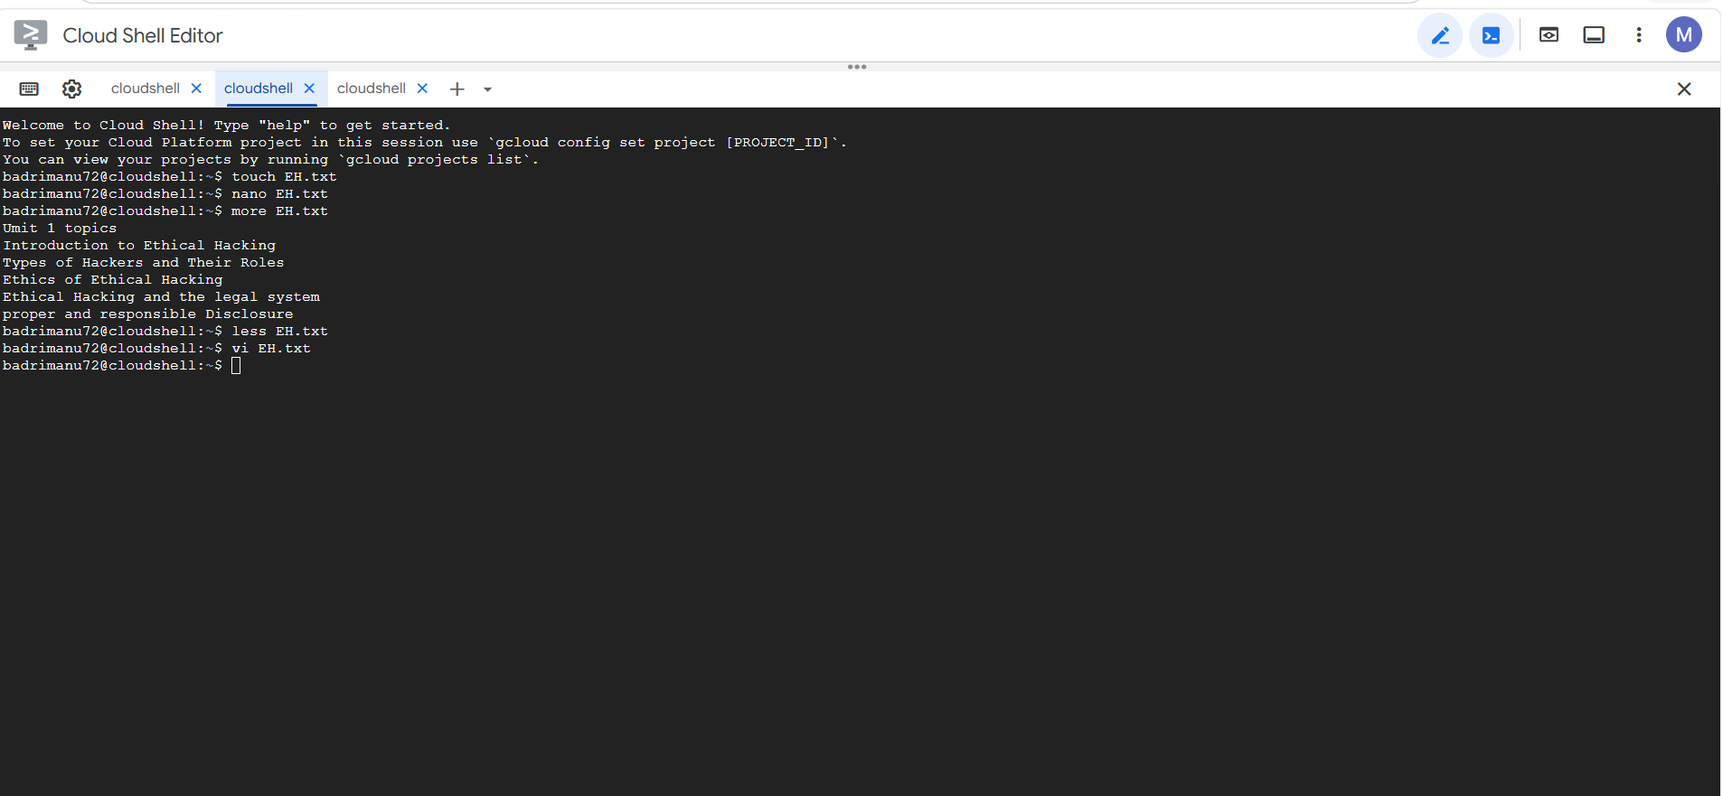
Result
Thus, the less, more, and vi commands were successfully executed and the results were displayed in Kali Linux Operating System.

